**Hands on # 1**

* Login into AWS
* **Navigate to VPC**
  + Default VPC is there which is attached with
  + Main route table
  + NACL
* **Verify the route table**
  + There is a main route table
  + Which is associated with three subnets
  + It has two entries
    - One to IGW
    - One to local route
* **Verify the NACL**
  + NACL is linked with default VPC
  + Three default subnets are associated with NACL
* **Verify the subnet**
  + 3 default subnets are three
  + Each one is integrated with the default route table & default NACL
* **Verify the IGW**
  + Internet gateway is linked with default VPC
* **Verify Security Group**
  + There is one default security group

**Hands on # 2**

* Login into AWS
* Create a VPC
  + Main route table and NACL are created automatically (Check the first entry in the below image)

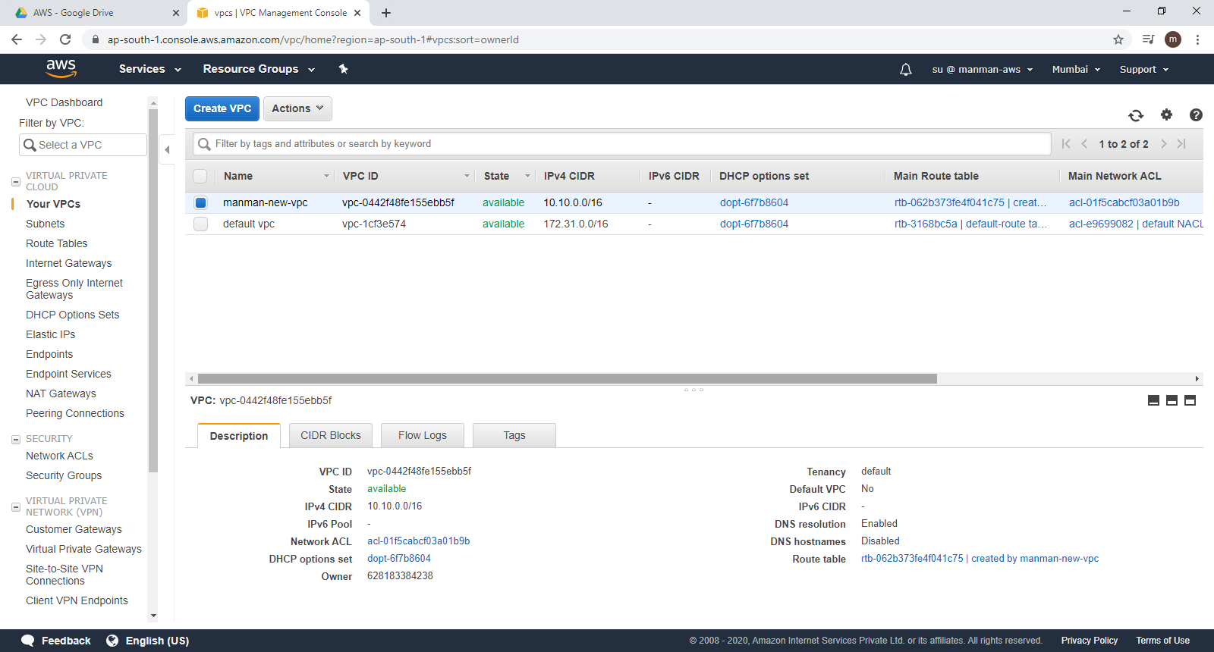

* Create a Subnet
  + route table and NACL are attached to the subnet

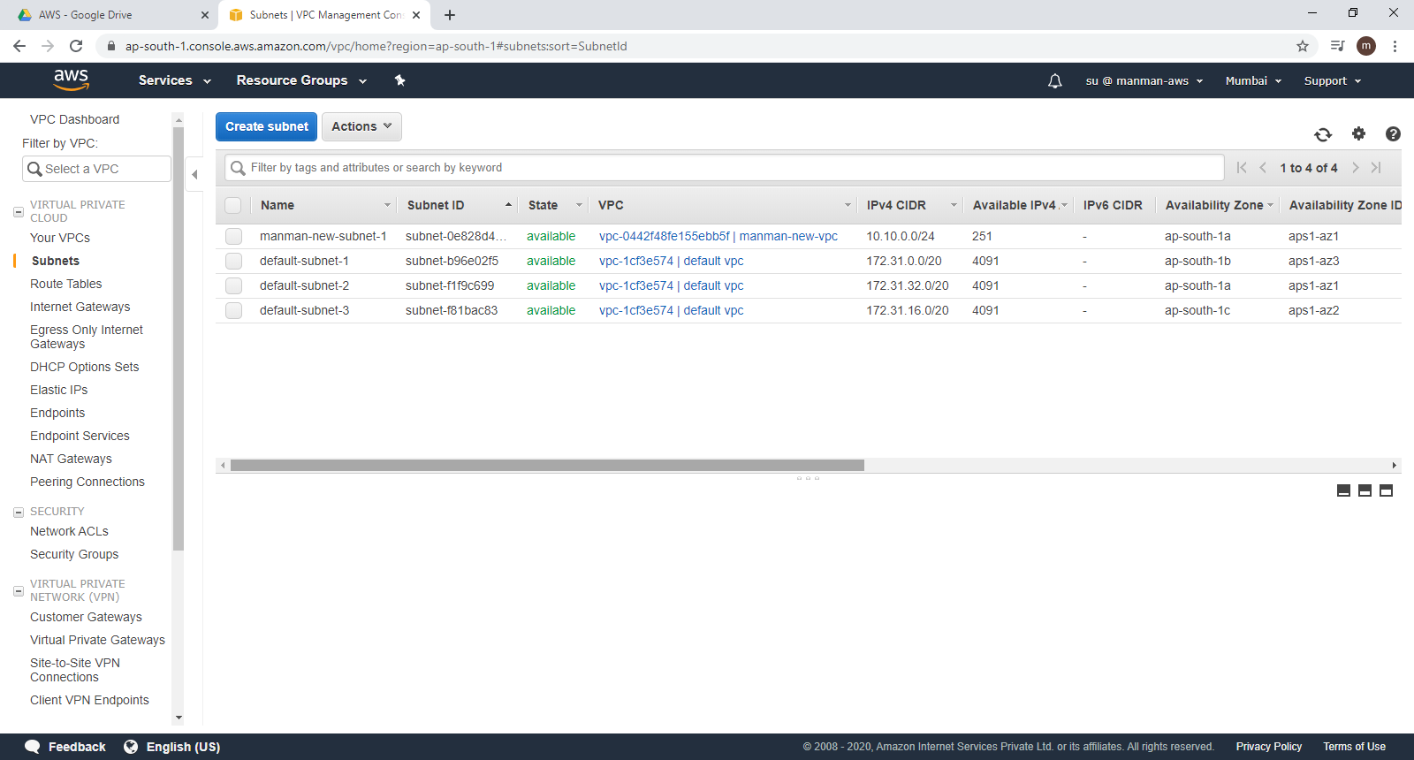

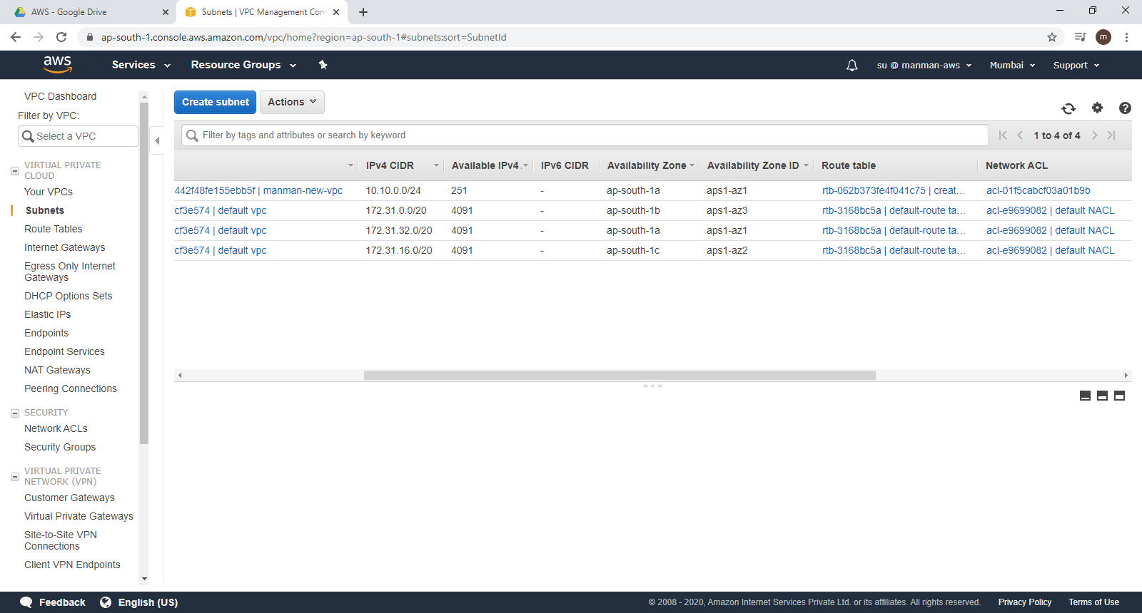

* Navigate to the route table
  + Default entry for local route is added
  + NOTE: There is no entry for IGW as there is no IGW associated with the newly created VPC

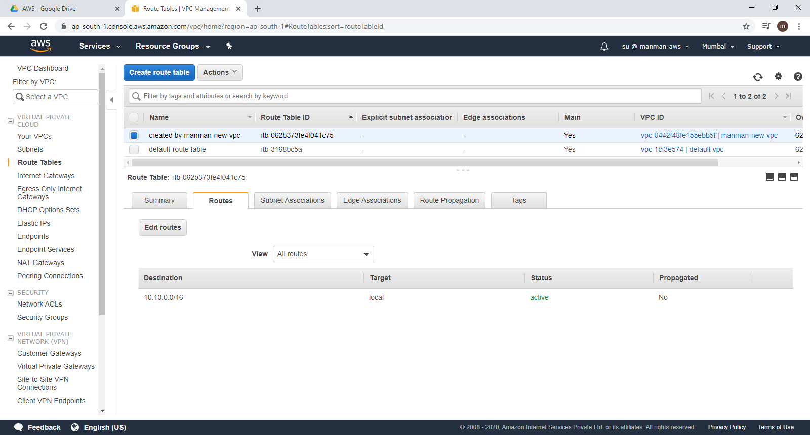

Where as if you see the below image (route table created by default VPC) , there is an entry for IGW

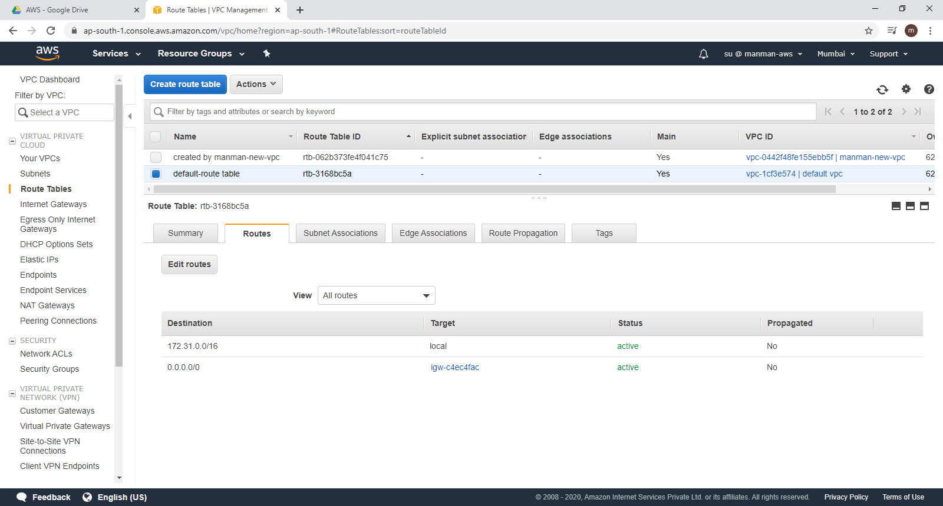

Internet Gateway:

Please note that when we create VPC , there wont be any internet gateway by default.

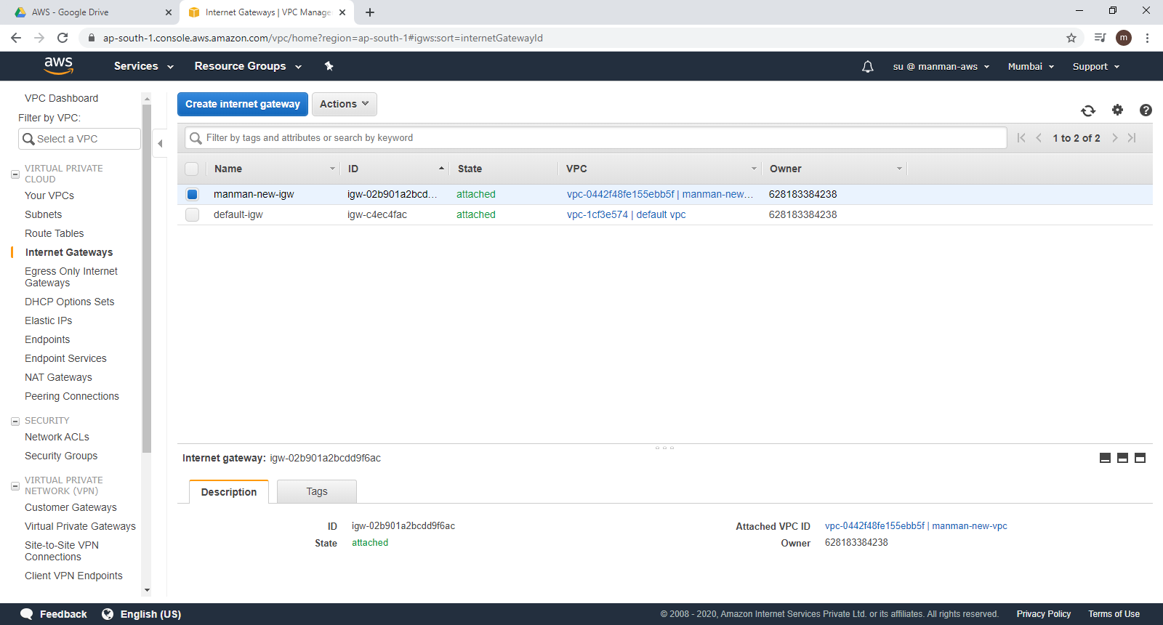

Route Table:

By default, when we create a VPC , a main route table will be created.

When we create a subnet - the main route table will be attached to it

Create a new route table:

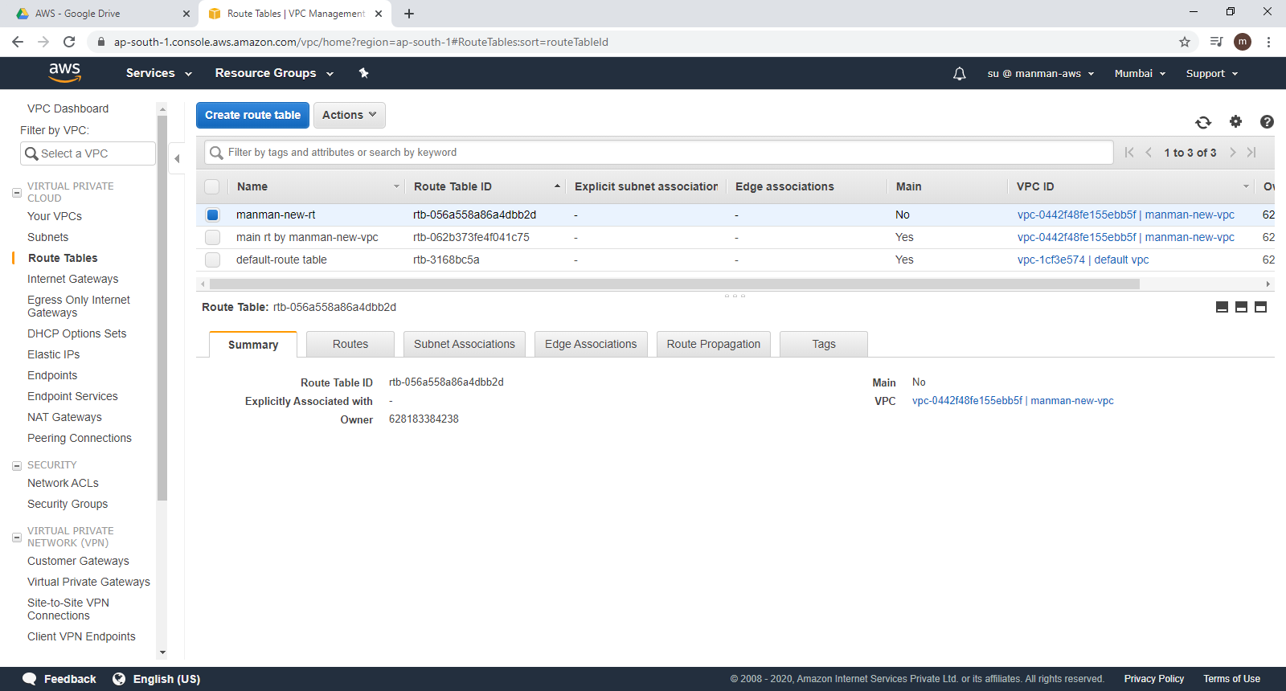

Add the IGW in the route entry:

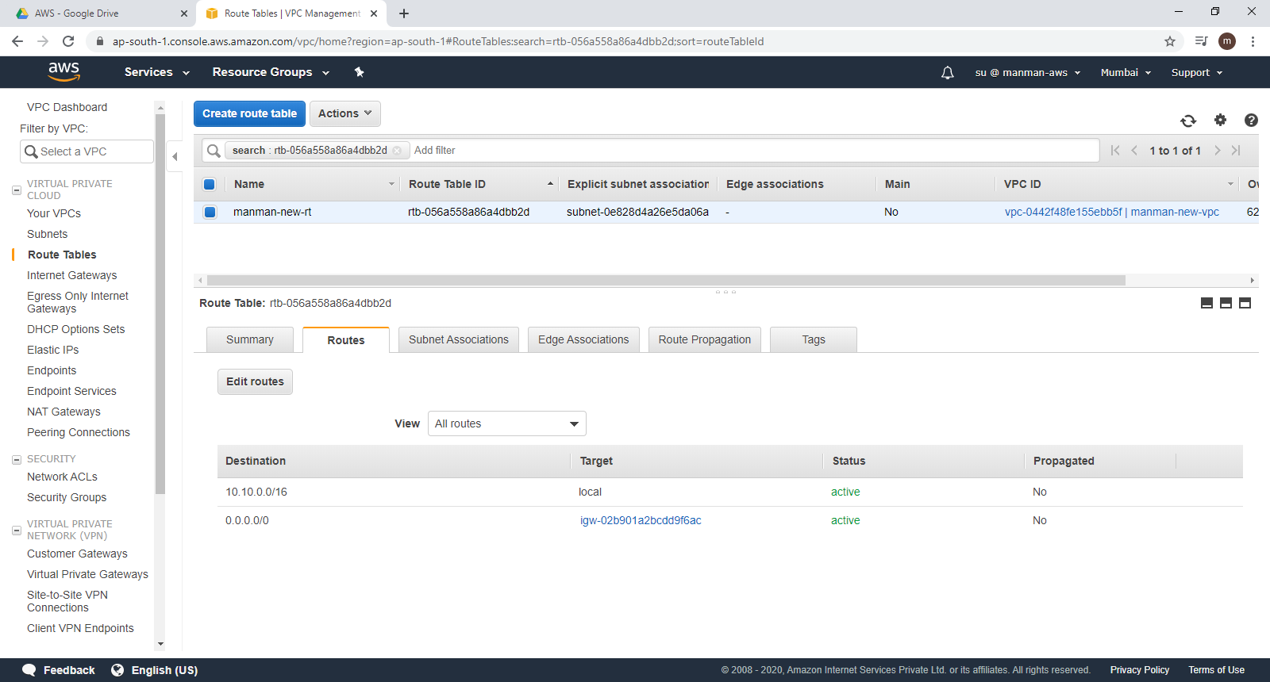

Attach the subnet to the newly created route table.

Now, navigate to our subnet ,

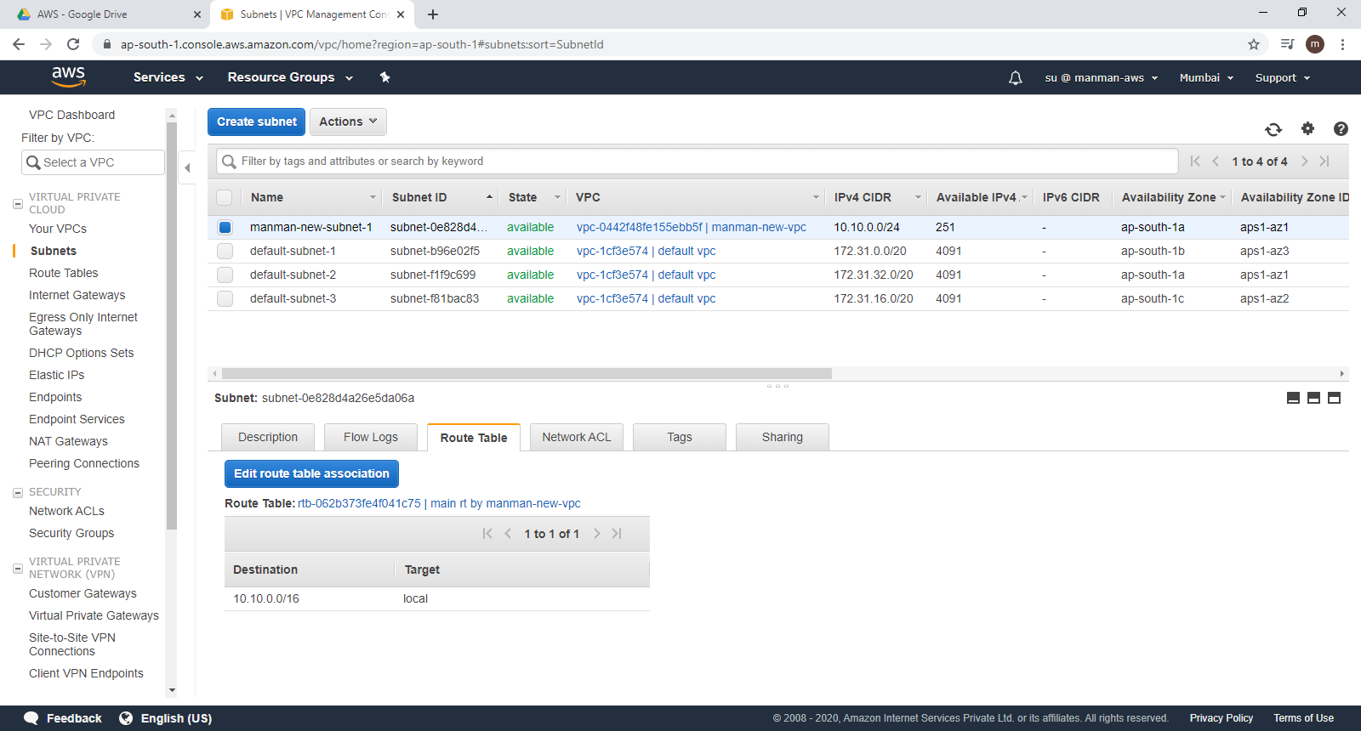

and configure the route table such that , remove the main route table and attach the newly created route table

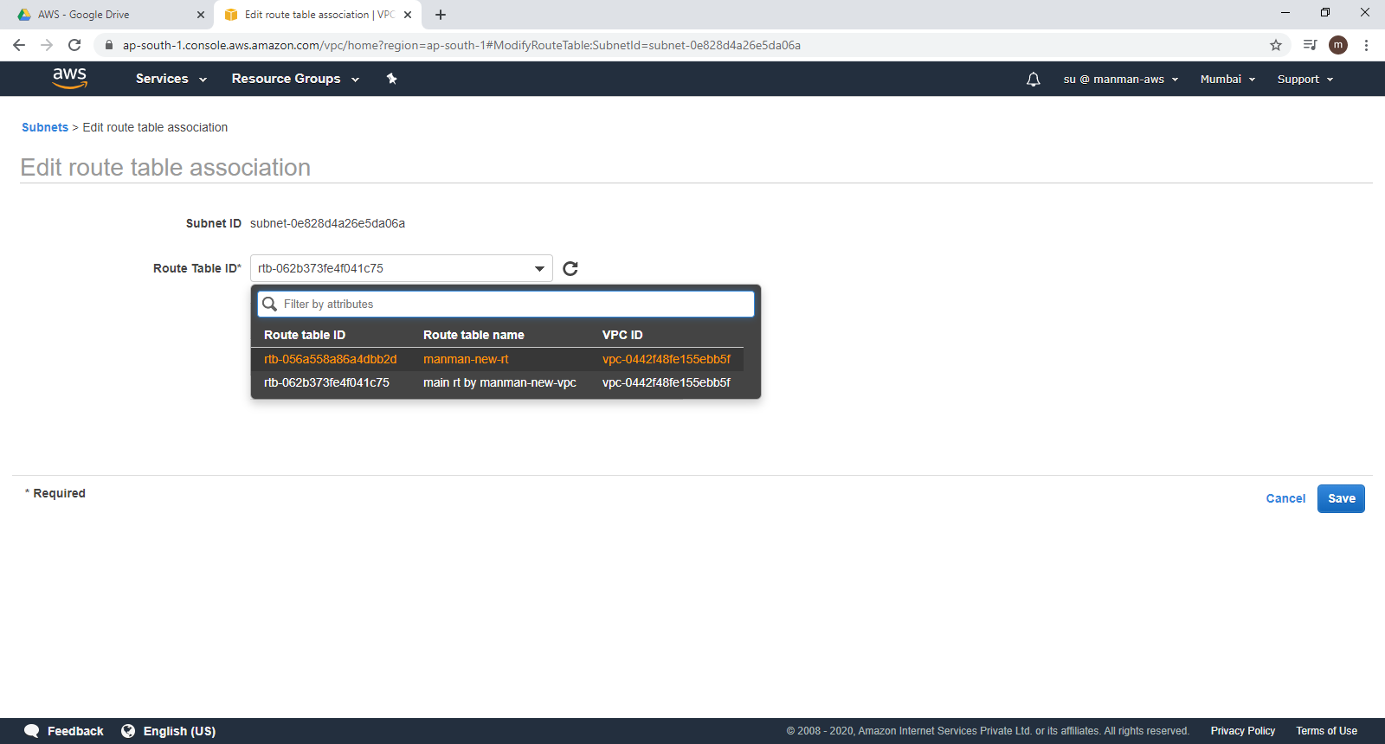

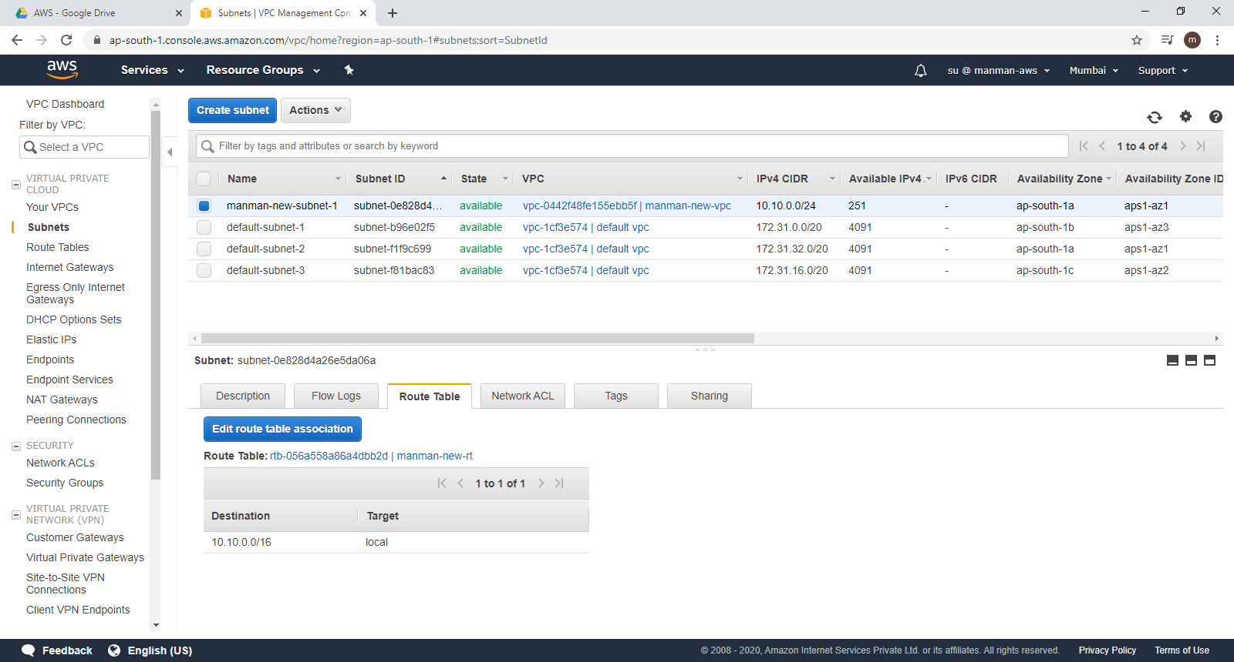

Summary:

Created our own

* VPC
  + Observed that main route table and NACL are created by default
* Created internet gateway and associated that with VPC
* Created subnet
* Created custom route table
* Associated the custom route table with the subnet
* Added an entry in the route table for IGW
* Edit the subnet and enabled ‘auto assign public ip’

Now the subnet can be called as public as

We have IGW

Entry to IGW in custom route table

ENabled auto assign public IP in the subnet

Hence, any instance created in this subnet can connect to internet